**GrainsMart**

**UML DIAGRAMS**

**Name:** Shubham Hiralal Giramkar

**Roll No:** 22318

**Class:** FY-MCA

**Div:** C

**Project Guide:** Dr. Milind Godase

USE CASE DIAGRAM FOR ORDER

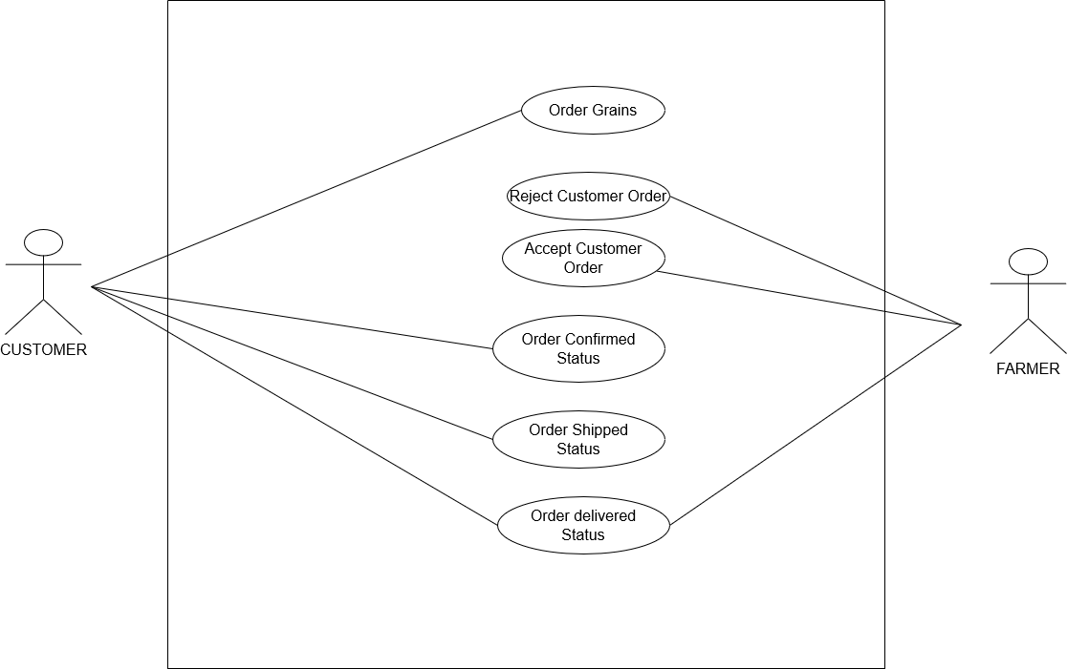

USE CASE DIAGRAM FOR PAYMENT AND DELIVERY

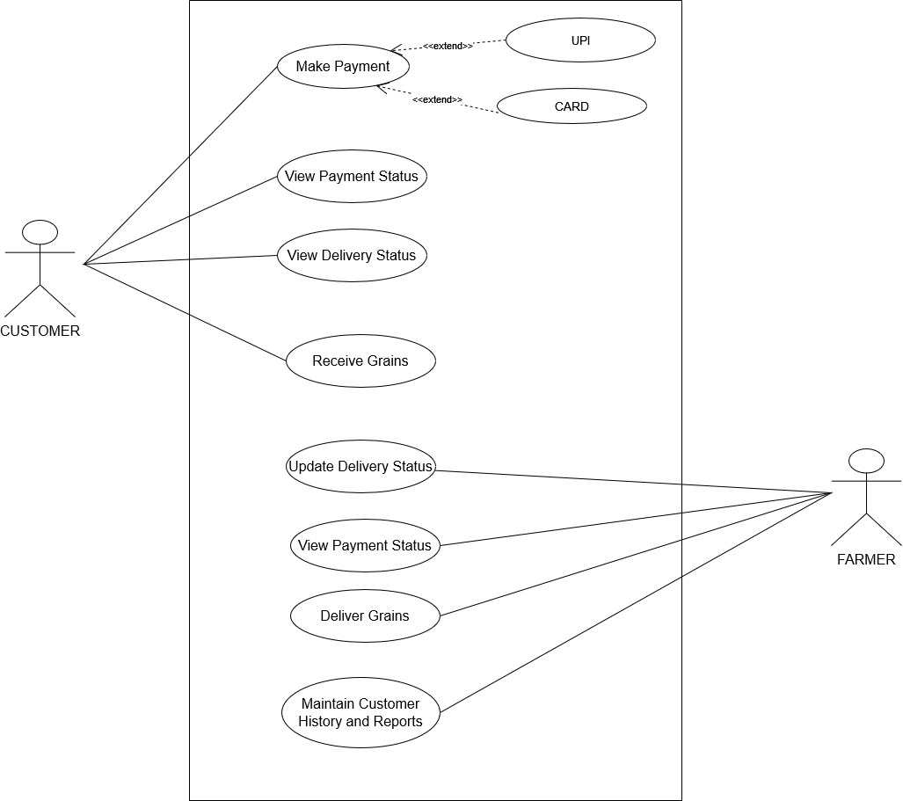

USE CASE DIAGRAM FOR GRAINS

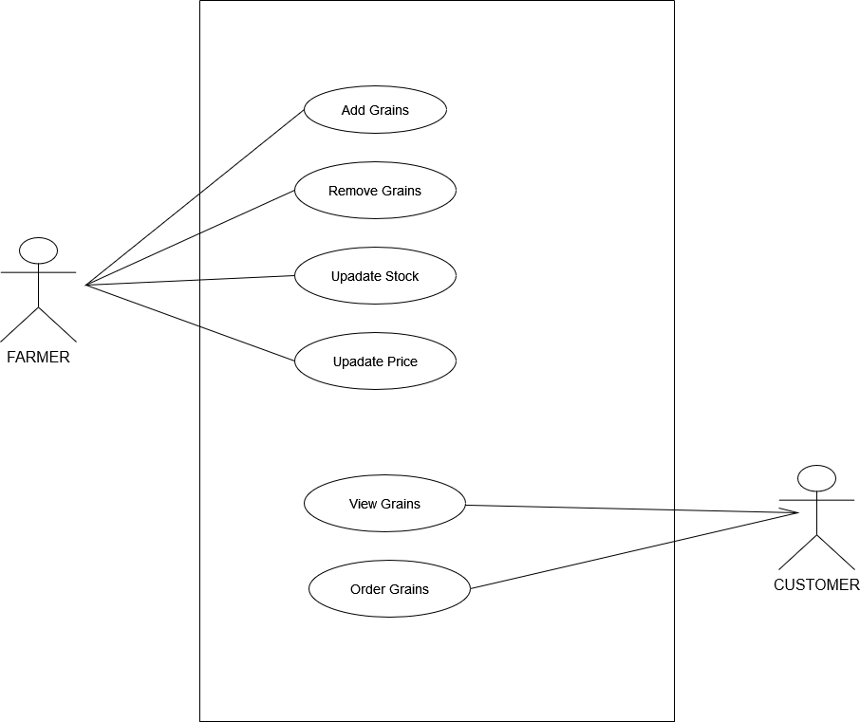

ACTIVITY DIAGRAM FOR ORDER

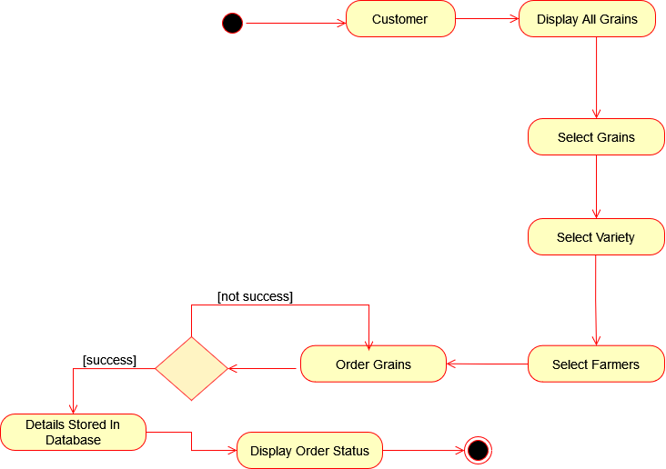

ACTIVITY DIAGRAM FOR PAYMENT AND DELIVERY

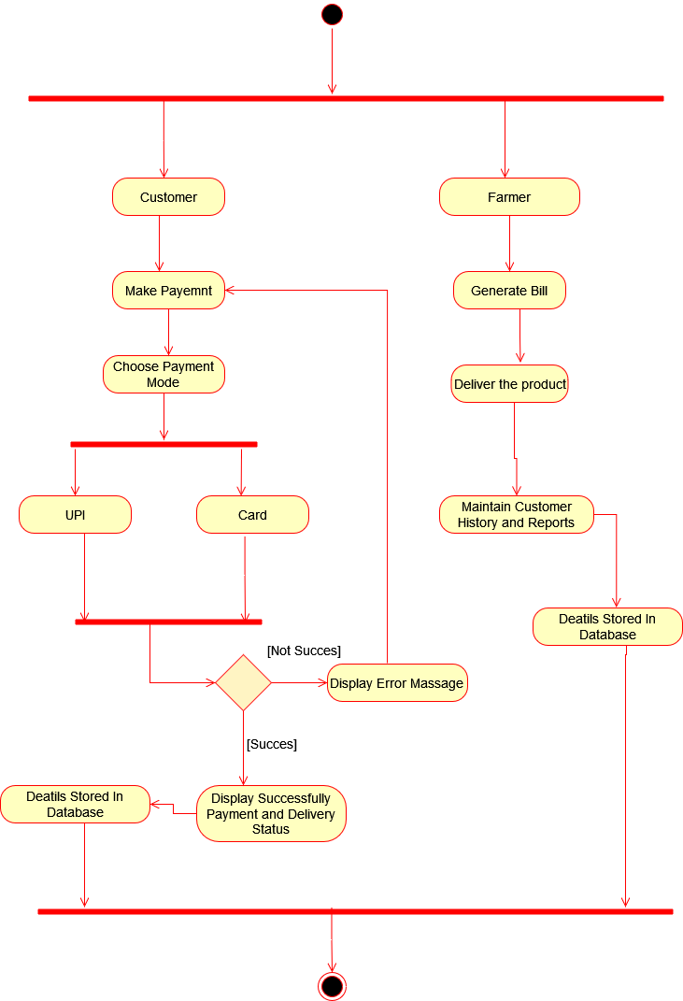

ACTIVITY DIAGRAM FOR GRAINS

